AI Fitness Trainer

*Progress Report #8*

# TL; DR

**On track (*Github:***[*AI-FitnessTrainer*](https://github.com/aminuabdusalam/AI-FitnessTrainer)*)***.** Completed trainer for **squats** exercise by **10/23.**

# Project Goals (Recap)

The goal of the project can be summarized as developing an **AI fitness trainer** embedded with **storage and recommender systems** and an **AI virtual mouse**.

The AI fitness trainer will help the user lose weight, gain muscle, and accomplish other fitness goals. In addition, it'd attempt to understand the client goals, develop a fitness routine, recommend a healthy eating plan, and ensure all exercises are performed correctly.

# Highlights

**Completed trainer for squats (**[Pull Request #5 · aminuabdusalam/AI-FitnessTrainer (github.com)](https://github.com/aminuabdusalam/AI-FitnessTrainer/pull/5))

* Created trainer for squats (squats.py) – class contains methods for finding angles between angle between the hip, knee and ankle and counting number of “successful/correct” squats based on the posture of both legs.
* Modified program (trainer.py) to contain squats as a choice of exercise, allow user to select the choice of exercise they want and present/adapt a frontend for checking the exercises based on the user’s input.
* Utilized the program in a live exercise session conducted by me as shown below.

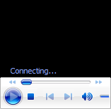

* As shown below, trainer now works for all of **curls**, **pushups, and squats**:

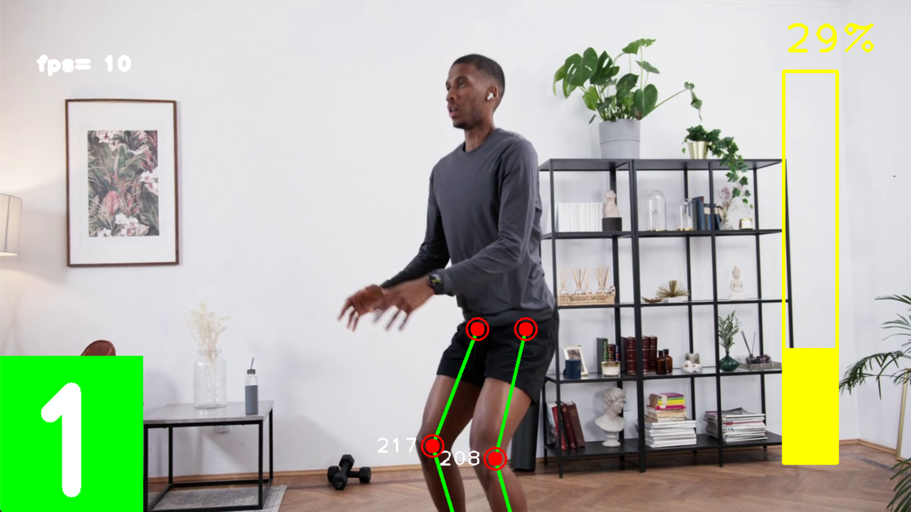

# Lowlights

None

# Next Steps

* Kickoff and partly complete storage system build by **10/31.**
* Add speech-to-text and text-to-voice for user to choose exercise and for program to call out the counts by **10/31**.

# Timeline

This section lists the milestones of the project spread across two semesters (Fall 2022 and Spring 2023).

|  |  |  |  |
| --- | --- | --- | --- |
| **Milestones** | | **ETA** | **Status** |
| **Requirements Gathering** (Project Idea, Project Proposal) | | 08/22 | Completed |
| **Design Exploration** (Setup and Installation of necessary technologies, Addition of Project to remote repo, Skill Preparation, Framework Project) | | 08/29 | Completed |
| **Implementation** | Complete Pose Estimation Build | 09/19 | Completed |
| Complete AI Personal Trainer for **Curls** | 10/11 | Completed |
| Complete AI Personal Trainer for **Pushups** | 10/18 | Completed |
| Complete AI Personal Trainer for **Squats** | 10/25 | **Completed** |
| Partly Complete Basic Storage System Build | 10/31 |  |
| **Quality Testing** | | 11/7 |  |
| **Midpoint Presentation Draft** | | 11/14 |  |
| **Midpoint Demo & Report** | | 11/21 |  |
|  | **WINTER BREAK** | | |
| **Project Review** (Current status and Re-evaluation of Next Steps as Needed) | | 01/16 |  |
| **Implementation** | Complete Storage System Build | 01/30 |  |
| Complete Recommender System Build | 02/20 |  |
| Complete Frontend/Website (Stretch Goals) | 03/13 |  |
| Complete Hand Tracking Build (Stretch Goals) | 03/13 |  |
| Complete AI Virtual Mouse Build (Stretch Goals) | 03/27 |  |
| **Quality Testing** | | 04/3 |  |
| **Final Presentation Draft** | | 04/10 |  |
| Final Demo & Report | | 04/17 |  |